**Project Report Template**

1. **INTRODUCTION**
   1. **Overview**

The Lok Sabha is composed of representatives of people chosen by direct election on the basis of Universal Adult Suffrage. The Constitution of India allows for a maximum of 550 members in the House, with 530 members representing the States and 20 representing the Union Territories. The 17th Lok Sabha was formed by the members elected in the 2019 Indian general election. Elections, all across India, were conducted in seven phases from 11 April 2019 to 19 May 2019 by the Election Commission of India.

* 1. **Purpose**

Social Impact: It brings a Clarity to know what are the weak places and which type of votes supports which party and which Category votes support which Party.

Business Model/Impact: By conducting an analysis the Party can identify areas for improvement and take steps to enhance the Votes, and increase voter satisfaction and loyalty. Improve its Party reputation, which can lead to increased Voter loyalty.

1. **Problem Definition & Design Thinking**

* 1. **Empathy Map**

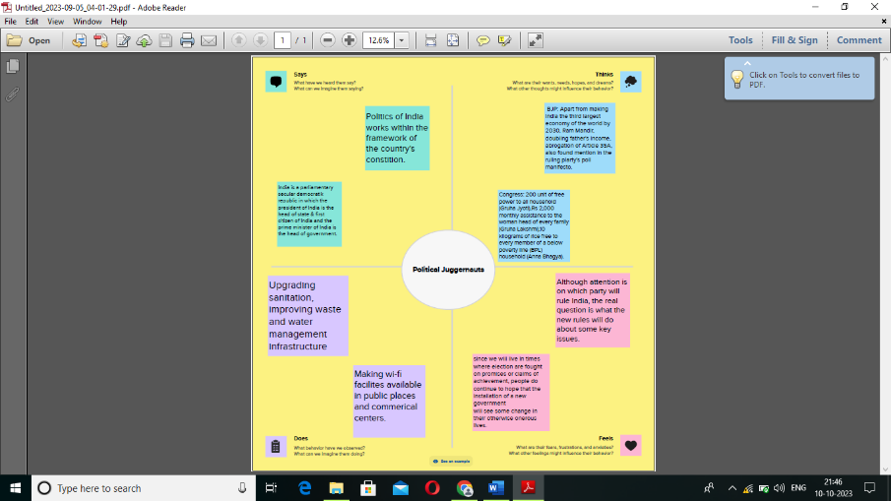

* 1. **Ideation & Brainstorming Map**

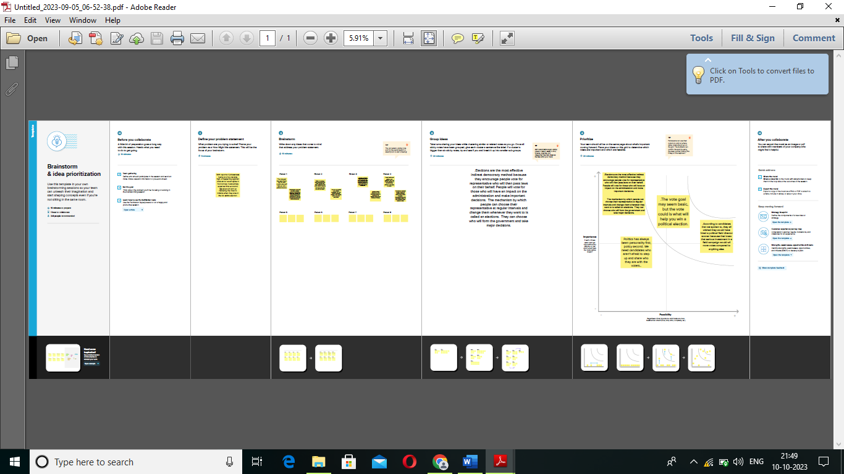

1. **RESULT**

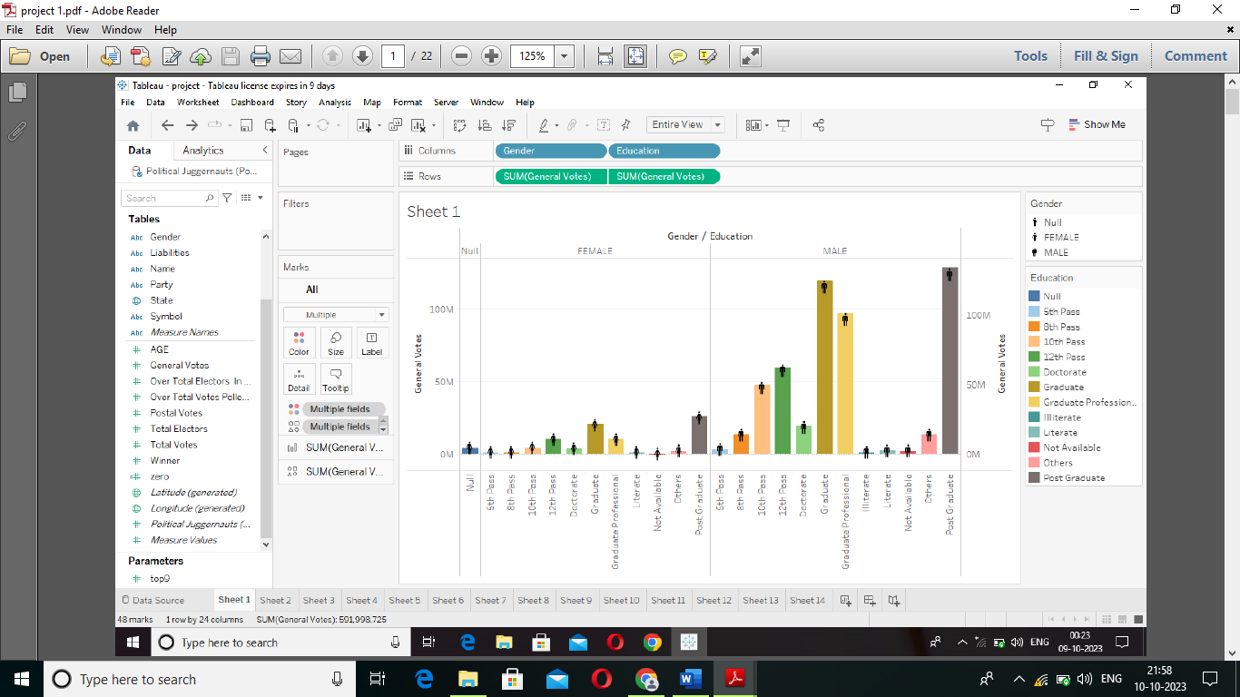



1. **ADVANTAGES & DISADVANTGES**

**ADVANTAGES:**

India gained independence from British role in 1947 and become a democratic republic. This was a great achievement for the Indians, who had struggled for independence for many years.

India has made significant economic development since independent. The economy of India is the sixth largest economy in the world, and it is one of the fastest growing economics in the world.

**DISADVANTGES:**

There is still significant social inequality in India. The disparity between people is very high in terms of wealth, educated and healthcare.

Corruption is a major problem in India. Corruption common in government and businesses, and it hinders economic growth and development.

1. **APPLICATIONS**

The juggernauts pulled out from the cross street, faster than he ought, faster than you might think a juggernaut could start up. They made a slow progress through the crowded town: the swinging cyclist, and the reverberating juggernauts.

1. **CONCLUTION**

Politics is above all the sphere thus need to take leadership winning confidence of bureaucracy and society at large. Bureaucracy should support the politician in attaining political and institutional desire/goals. Both need to hand in hand.

1. **FUTURE SCOPE**

It deals with the ideas and principles that from the basis for Constitutions, governments, and social life in an organized manner. It elucidates the meaning of concepts such as freedom, equality, justice, democracy etc.

1. **APPENDIX**
2. **Source Code**

Attach the code for the solution built.